Programming Concepts - Tutorial 5
HIT265 – C Programming
Question 1
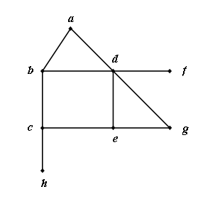
Apply the Depth First Search algorithm to each of the graphs in Figure 1. Include the tree at each stage in your answer and give the order in which the vertices are visited. Remember to use the alphabetic/numeric convention – this will tell you which vertex to start the algorithm at.
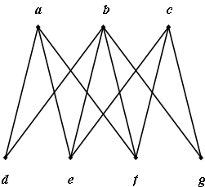
(a)
(b)

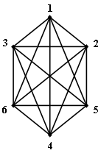
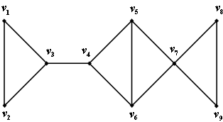
(d)
(c)

Figure 1
Question 2
Identify the cross edges and back edges (where they exist) for each of the graphs in Figure 1, as determined by your DFS spanning tree.
Question 3
Apply the Breadth First Search to each of the graphs in Figure 1. Include the tree at each stage in your answer and give the order in which the vertices are visited.
Question 4
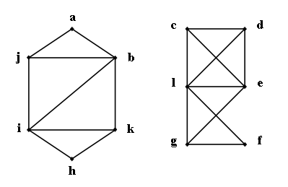
Apply the DFS algorithm to the graph in figure 2. Note that each component will have to be handled separately.

Figure 2

